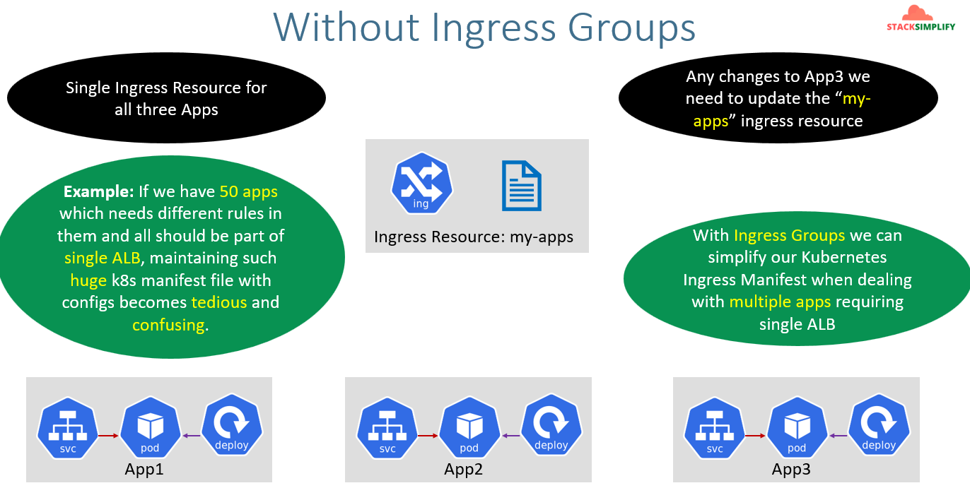
Without Ingress group if we want to deal with 50 apps with rules it would be very tough. Here we will separate the each App’s ingress resources separately in a file and then we will merge them together to create a single ALB.
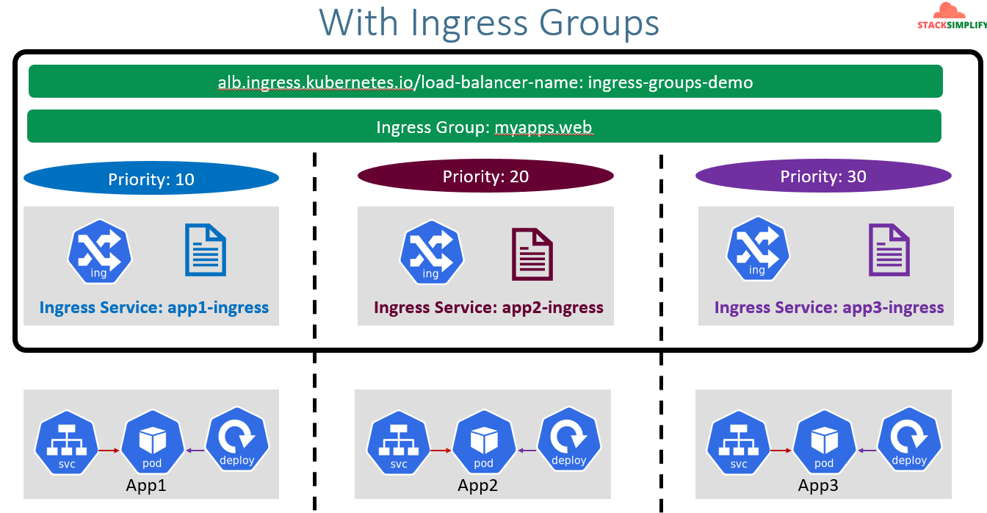
If you see above pic, we have sseparated the ingress resource separately. We will mention these each ingress resource with ingress group name annotation. In addition I’m going to define the priority for each app as App1, App2, App3 as 10,20,30. If put the priority in the Load balancer the rules going to configure in the same order.In Ingress group term we will call priority as ingress group order. In LB term it will be rule priority number. Please see the pic for better understanding. 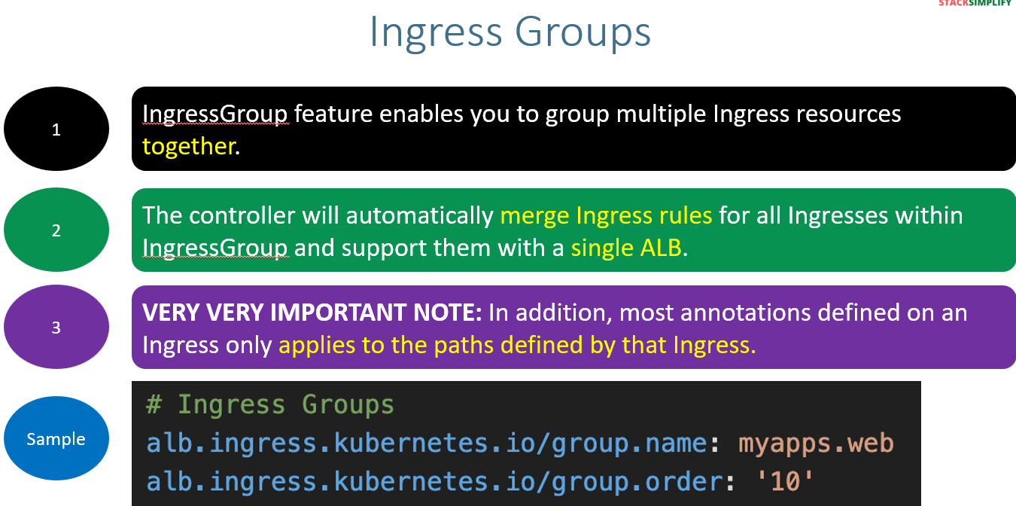
Each apps manifest file structure will look like below:
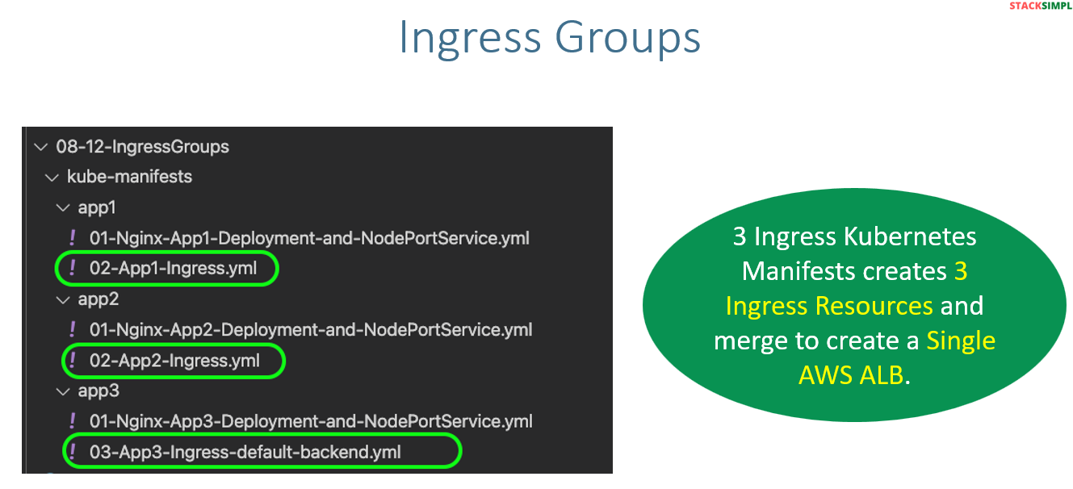
Copy the scripts from instructor repo aws-eks-kubernetes-masterclass/08-NEW-ELB-Application-LoadBalancers/08-12-IngressGroups at master · stacksimplify/aws-eks-kubernetes-masterclass .
In the scripts we need to make changes to below values
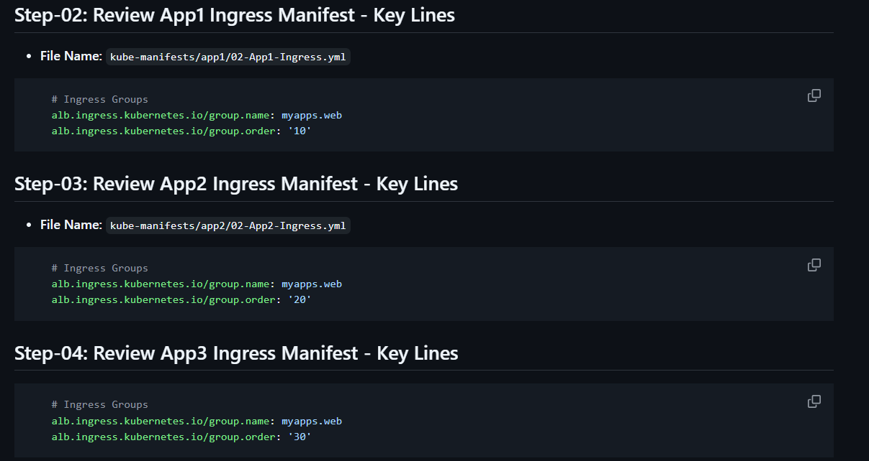
If you observe the ELB name will be same it won’t change.
After applying run ingress get command.
For apps 2 and 3 even though the ALB DNS is not showing as attached it was attached to the application this you can see in listeners in LB and parallelly you can verify it in the browser.

